**Unosim gsm alarm dialer caller**

1. Arduino Uno

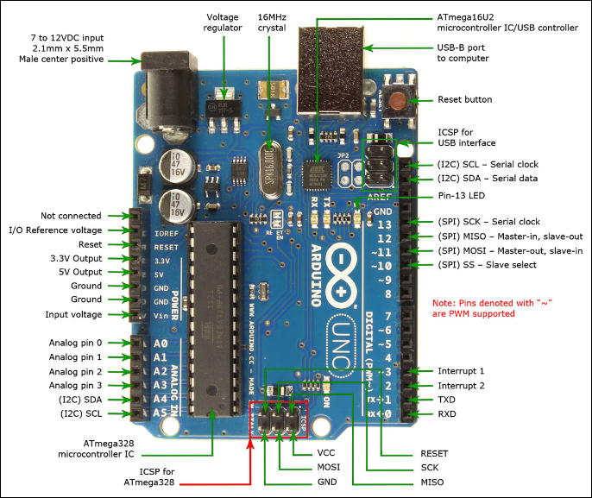

Figure 1 Board

1. GSM module

<http://www.geeetech.com/wiki/index.php/Arduino_GPRS_Shield>

1. Dx bus digital inputs\outputs:

Security input = D5 

Activation: Connect to ground.

Configuration of modes in “Unosim configuration tool”.

SMS pin for receiving status of alarm on or off. Possible enter own text of sms.

If pin connected to ground – sending alarm ‘On’ message.

If pin not connected to ground (released) – sending alarm ‘Off’ message.

* Relay output = D10 

Activation: Connect to ground.

Configuration of modes in “Unosim configuration tool”.

Relay output pin for relay. If incoming call from authorized callers (users from Alarm1 or Alarm2 or Alarm3), relay will connect for 2..10 seconds after the call on device.

Possible enter own delay between 2-10 seconds.

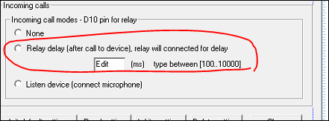

* Alarm input = D2,D12 

Activation: Connect to ground.

Configuration of modes in “Unosim configuration tool”.

Possible switch call or/and sms mode.

If pin connected to ground – calling or/and sending message to Alarm1 or Alarm2 or Alarm3 users.

If pin not connected to ground – nothing.

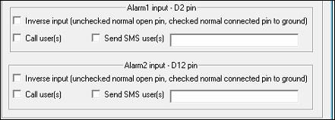

* Mode for incoming call and listen around.

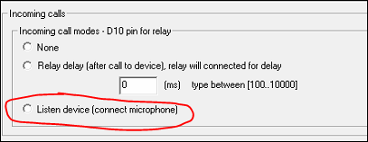

* Upgrade firmware = D4 pin to ground.

Activation: Connect to ground.

Update firmware in “Unosim configuration tool”. See figure 4.

1) Push Reset button.

2)Run “Upgrade firmware” button in “Unosim configuration tool”. See instructions in program and figure 2.

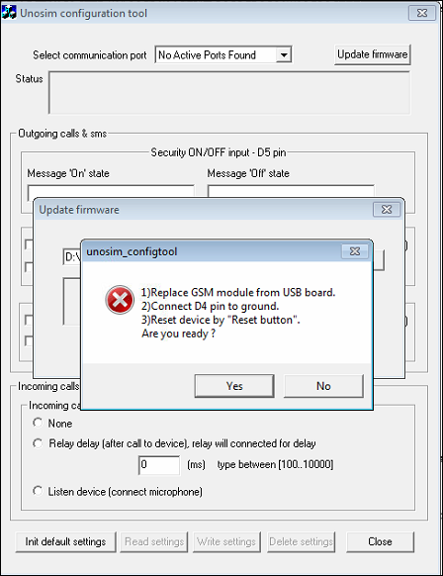

Figure 2 Update firmware

* “Security on/Off” D5 activation.
* “Input 1” & “Input 2” D2, D12 activation.
* D10 pin relay output. (use 5volt relay)

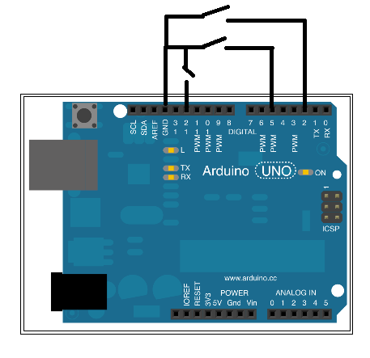

Figure D2 D5 D12 pins - actiovation

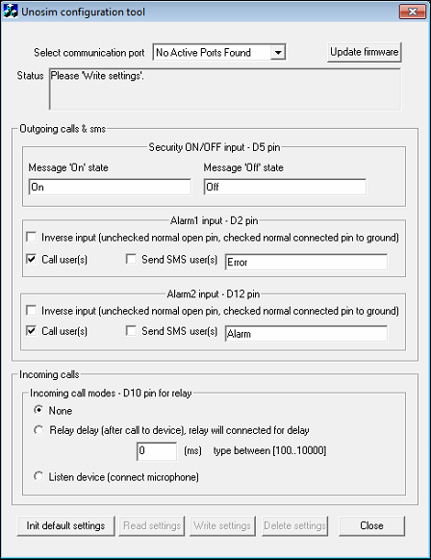

Figure 4 “Unosim configuration tool” – default settings